# Pets

You need to add 20 things to this document. (Make sure to number them just as I did in the example.) It may be helpful to copy and paste this list and then fill it in as you go along. All image names must start with your location, e.g yellowstone_sunset.jpg unless you are using a link from the internet.

## Pet Name: Rocket

1. Primary Image of Pet: 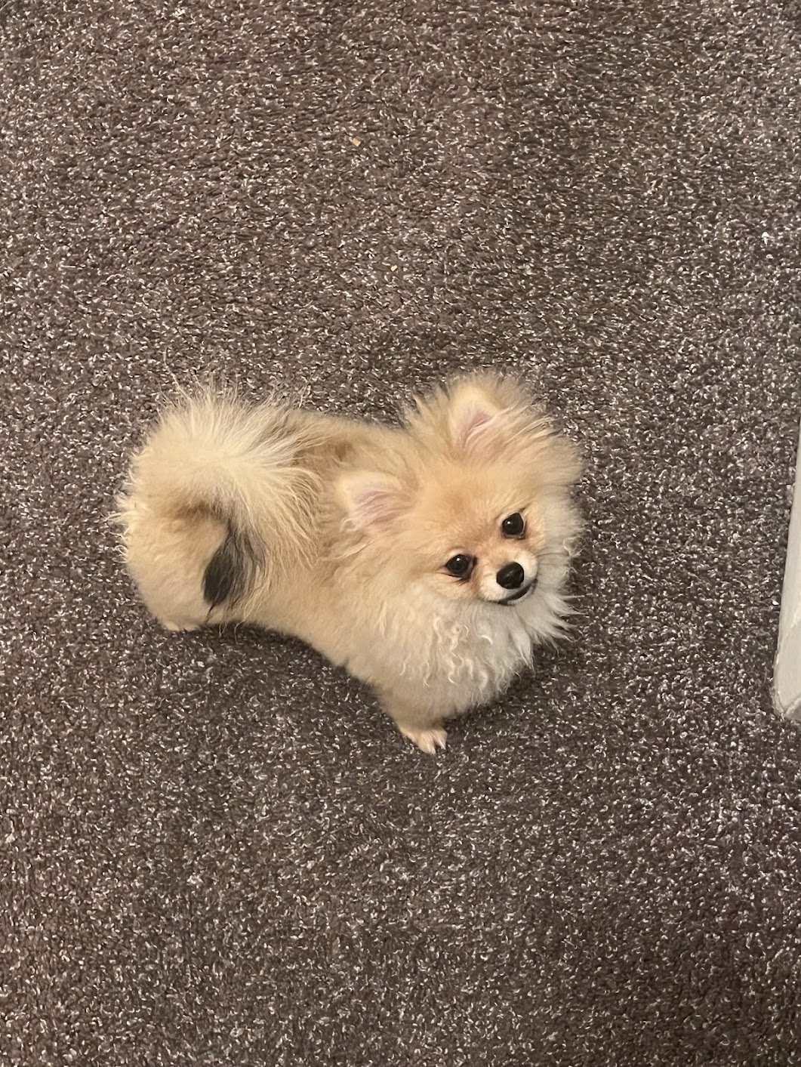
2. rocket_primary.jpg
3. Cute, small and yellow pomeranian
4. Rocket (also named huihui) is a 6-month pomeranian puppy with big eyes and a small, black cute nose. Rocket is named rocket because he runs so fast and energetic all day without even having some rest. Rocket loves to carry his little toy walking around the house and jumping towards my bed.
5. Rocket is friendly to all human beings. He will be a little shy at first, but will ‘say hi’ to you after a few seconds. He is also friendly to dogs, especially the small breed, because the large size dogs are hard for him to smell lol. If you meet rocket, don’t hesitate to say hi to him!! He will be super happy the whole day.
6. **Photo Gallery**
7. rocket_dinner.jpg
8. Rocket is eating his dinner.
9. rocket_wants_to_go_out.jpg
10. Rocket wants to come out of the playpen.
11. rocket_childhood.jpg
12. Rocket is in his childhood.
13. rocket_kitchen_clip.mp4
14. Rocket is trying to hunt the kitchen clip.
15. **Likes**
16. Chewing bones
17. Running
18. Chasing
19. Huiyu Su (Bonnie)

## Bacon Q Dog

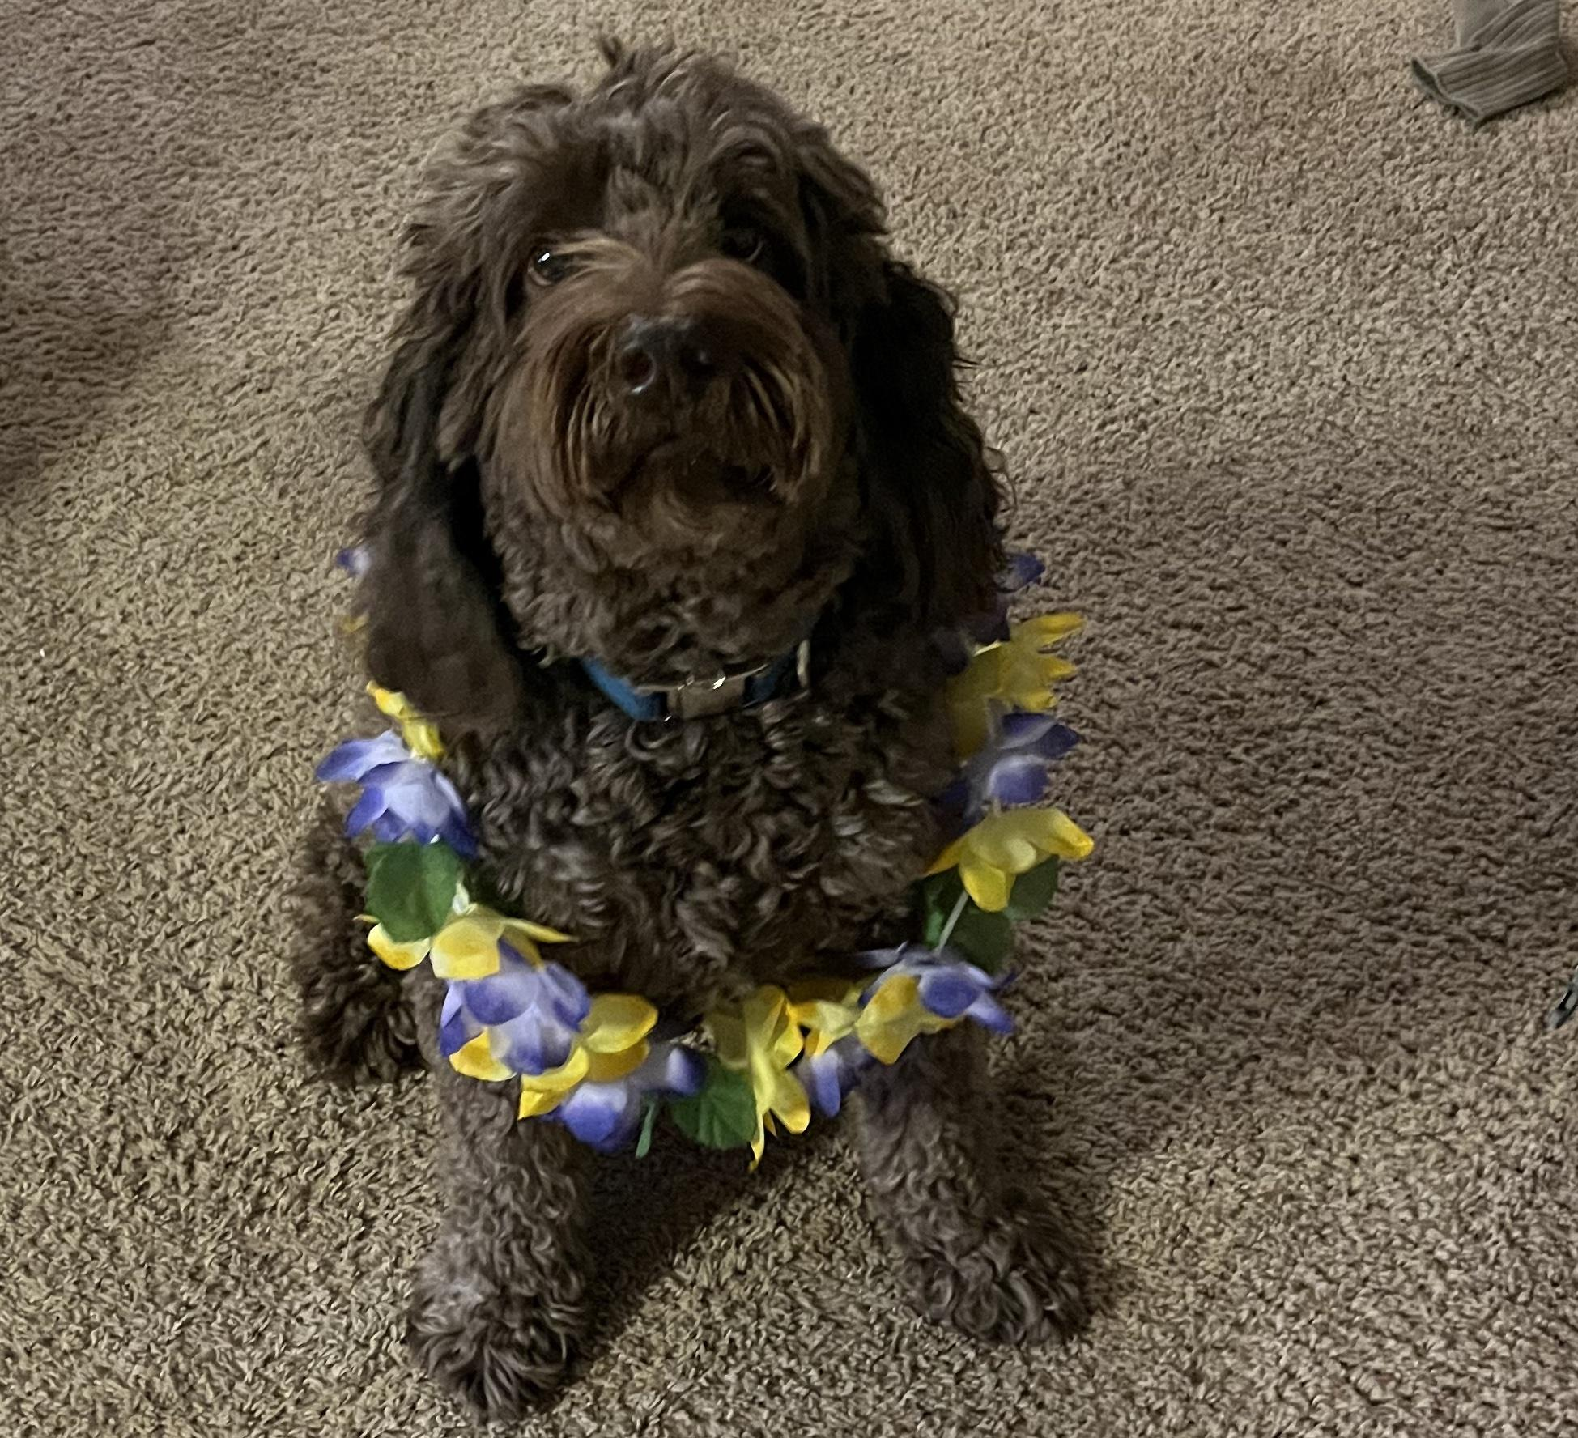

1. bacon.jpg
2. Brown labradoodle wearing colorful lei
3. Bacon Q. Dog is a 9yr old labradoodle. He prefers to spend his days lounging among the three different beds/couches that his family has gifted him. He enjoys a walk or two around the neighborhood, as long as he can pretend that he doesn't see any of the other animals to avoid the embarrassment of not wanting to admit he has no wolf-like skills in chasing them.
4. At night just as the rest of the family is ready to relax, Bacon suddenly wants to release all of his energy. He will place his toys on a mini couch and frantically drag the couch around, giving his toys "a ride." There is also a lot of rolling. Lots and lots of rolling.
5. **Photo Gallery**
6. bacon_bandana.JPG
7. Brown labradoodle wearing an orange bandana
8. bacon_graduation.JPG
9. Small labradoodle puppy wearing a graduation cap and gown.
10. bacon_agility.mov
11. Girl and dog demonstrating a sit and stay procedure
12. bacon_halloween.JPG
13. Brown labradoodle wearing a pirate costume
14. **Likes**
15. Belly rubs
16. Playing tug-of-war
17. Sneaking onto the couch
18. Colleen van Lent